Using the BrailleNote Touch as a Braille display
Did you know that you can run a screen reader (such as JAWS and Window-Eyes on your Windows computer or VoiceOver on your Mac) using your BrailleNote Touch as its Braille display? You can also read and type information in Braille to your iPhone.
The Touch offers flexible connectivity options. You can connect your Touch through the USB port. It also allows you to enjoy the freedom of wireless Bluetooth connectivity.
Table of contents
Windows computers 2
Connecting via the USB port 2
Connecting via Bluetooth 2
Setting up your Windows computer and screen reader 3
JAWS driver installation 3
Mac computers 7
Connecting via Bluetooth 7
iPhone iOS 7
Command Summary 13
JAWS command summary 13
Basic Commands 13
PC keyboard emulation for the Touch 15
Modifier Keys 15
Function Keys 15
Modifier commands 16
VoiceOver iOS command summary 16
Basic navigation commands 16
Reading commands 17
Information commands 17
Rotor commands 17
Edit commands 17
Miscellaneous commands 17

Windows computers

Connecting via the USB port
The simplest way to use the display is through the USB port. Follow these 3 steps:
- Prepare your computer and screen reader.
If it is the first time you use your computer with the Touch, you must follow the steps described in the section Setting up your Windows computer and screen reader below. If you prefer to connect using Bluetooth, follow the instruction described in the Connecting via Bluetooth section.
- Set your BrailleNote Touch to Terminal mode.
On the Touch, press Space with Braille keys 1 to 6 or the Home Button to go to the main menu.
From the main menu, press B to select the Braille Terminal for screen reader option and activate it by pressing a cursor router key or enter.
You will be prompted “Select how you want to connect to your device”.
Press U to select USB and activate the USB option by pressing enter. You will be placed in the Braille Terminal mode.
Using the USB cable, connect the computer to the USB port on the left side of the BrailleNote Touch. You will hear a rising tone indicating that the PC has recognized the connection.
On your PC, turn on the screen reader of your choice.
- Now you are ready to enjoy your Touch display!
Information from any PC application will be shown in Braille and you can use the various sets of commands available in your screen reader to read and navigate the PC information. Please refer to the Appendix for more information about JAWS, Window-Eyes set up and commands.
To learn how to use your Touch as a Braille display via a wireless connection with your Windows, Mac computer or iPhone, please refer to the following sections.

Connecting via Bluetooth
To use the Touch with a screen reader via Bluetooth, follow the next steps.
On the Touch, press Space with Braille keys 1 to 6 or the Home Button to go to the main menu.
From the main menu, press B to select the Braille Terminal for screen reader option and activate it by pressing a cursor router key or enter.
You will be prompted “Select how you want to connect to your device”.
Press B to select Bluetooth and press Enter. You will be placed in the Braille Terminal mode. If Bluetooth was off in the Android settings, it will be turned on automatically.
On the PC, perform a Bluetooth search. When the Brailliant/BrailleNote Touch is displayed in the list of Bluetooth devices, select it.
The device should then pair with the BrailleNote Touch, and an incoming Bluetooth virtual serial port will be set up on the PC.
You should now check the ports list in the Windows Device Manager to find out which COM port number has been assigned to the incoming Bluetooth serial port.
The Device Manager will show the COM port number assigned. Make a note of this number.
On the PC, in your screen reader, set the active Braille display COM port to use as the relevant Bluetooth serial port COM number.
Select your device in the Bluetooth settings. From the contextual menu, select Connect and press Enter. Follow the on-screen instructions. On your Touch, you will get a pairing request. Select the Pair button and press Enter to complete the Bluetooth pairing process.
If using JAWS, you may then need to quit and restart it.

Setting up your Windows computer and screen reader
To set up your computer, you will need to install the JAWS driver if you are using JAWS. If you are using other screen readers, the drivers are already included.
The JAWS BrailleNote Touch driver is included in the Braille Terminal Tool. You can download it from our Web site at: www.humanware.com/support/braillenote_touch

JAWS driver installation
Follow the instructions below to install the BrailleNote Touch driver for JAWS version 10 or later.
- Launch BrailleTerminalTools.
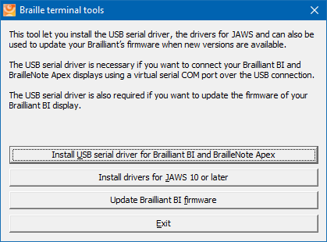

- Select Install drivers for JAWS 10 or later or press Alt-J to start the installation.

- Select NEXT to continue.
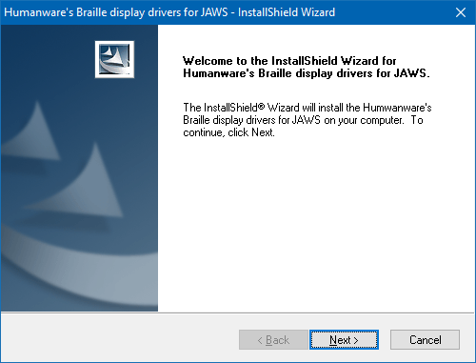
- On the next screen, all the HumanWare Braille drivers are checked by default. You can uncheck the ones you do not need.
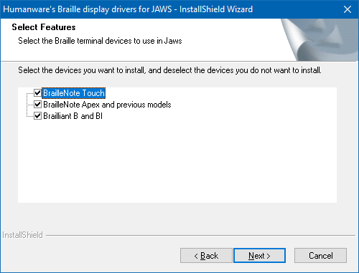
- Select Next to use your BrailleNote as your default Braille display.
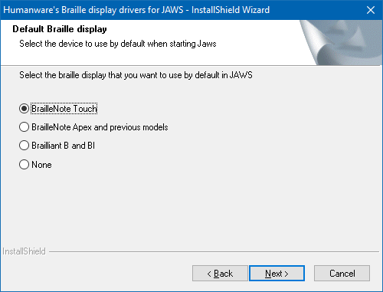
- If you unchecked the BrailleNote Apex or are only installing the Touch drivers, skip to step 7. On the next screen, select the BrailleNote Apex communication port from the list. If your Apex is connected to the USB client port, it will be automatically detected by your computer.
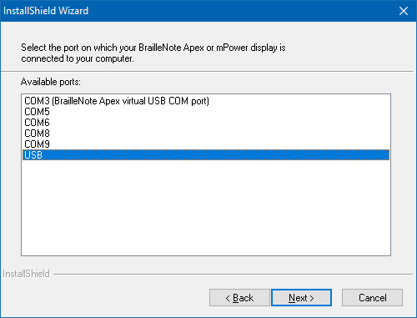
- Select Install to continue.
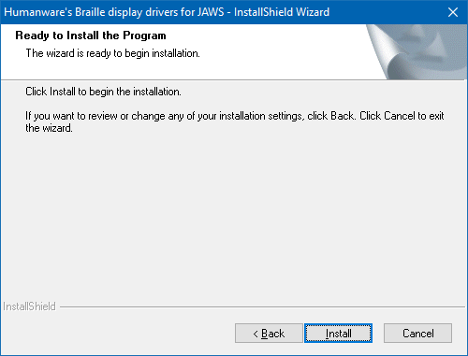
- Click Finish to conclude the installation process.
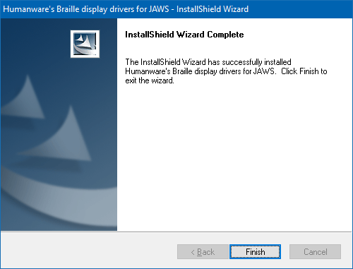
- If your JAWS is already running, close it and restart it for changes to take effect.

Mac computers

Connecting via Bluetooth
To establish the connection, do the following:
On your MAC, from the desktop:
- Open VoiceOver Utilities by pressing the VO keys with F8. Interact with the table of categories and move to Braille.
- Stop interacting with the table and move the VO cursor to the Displays tab and press the VO keys with Space to activate that tab.
- Move the VO cursor to the right until you find the "Add Braille Display" button and select it. The Mac will search for Bluetooth Braille displays.
- When you hear that the Mac has found a display, move the VO cursor to the right to the table of discovered displays and interact with the table. Move the VO cursor down and find the Brailliant/BrailleNote Touch.
- Stop interacting with the table.
- When you no longer hear “busy” from the progress bar, move the VO cursor to the right, find the select button and activate it.
- A pairing request window will appear, accept it by pressing Enter.
- On your Touch, a pairing request will also appear. Select the Pair button and press Enter to complete the pairing process.
- If the pairing is successful, the Touch will display the contents of the VO cursor.
Note: USB support will be done by Apple in a future version of the Mac OS.

iPhone iOS
The Touch can be paired with the iPhone running iOS as a Bluetooth Braille display and provides Grade 2 Braille input and output.
The pairing has to be initialized from the phone, just as you would to pair with any other keyboard or Bluetooth device.
On the BrailleNote Touch, make sure Bluetooth is activated in the Android settings. Enter Braille Terminal mode. Change your terminal port to Bluetooth. The procedure is described in the section "Connecting your Touch via Bluetooth".
To make the connection, do the following:

- Tap on the settings application from the Home screen.   | - Tap on "General."  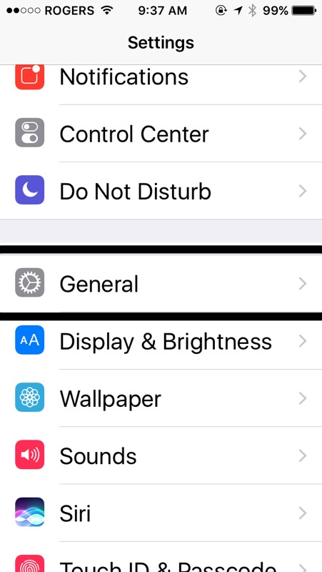

- Towards the bottom of the screen, tap Accessibility.  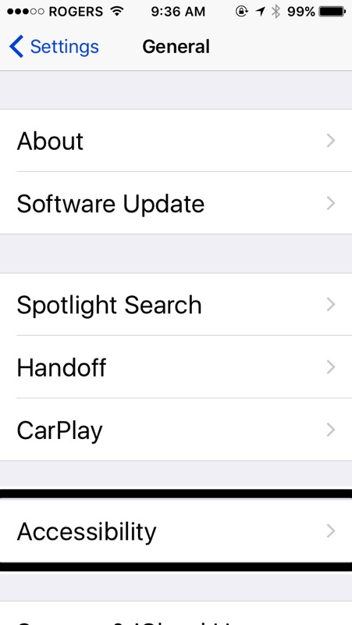 | - Tap on VoiceOver. Make sure it is set to On.  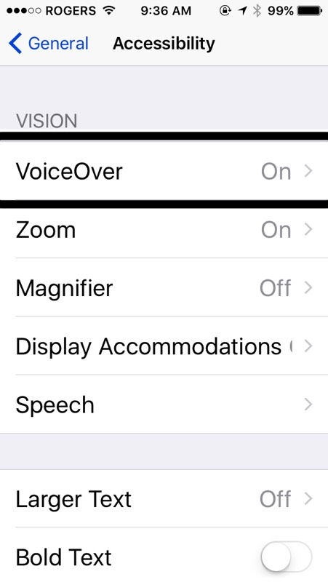

- Double tap on Braille.  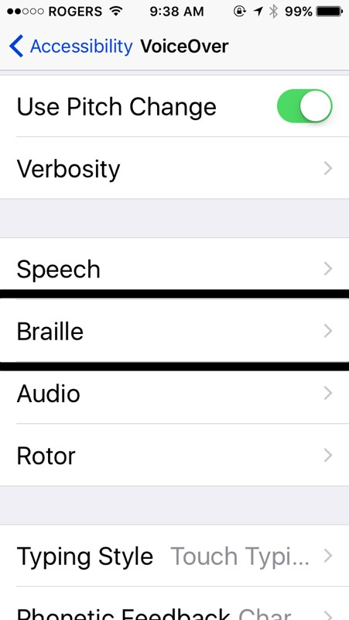 | - If Bluetooth is not enabled, double tap "Yes" to enable it.  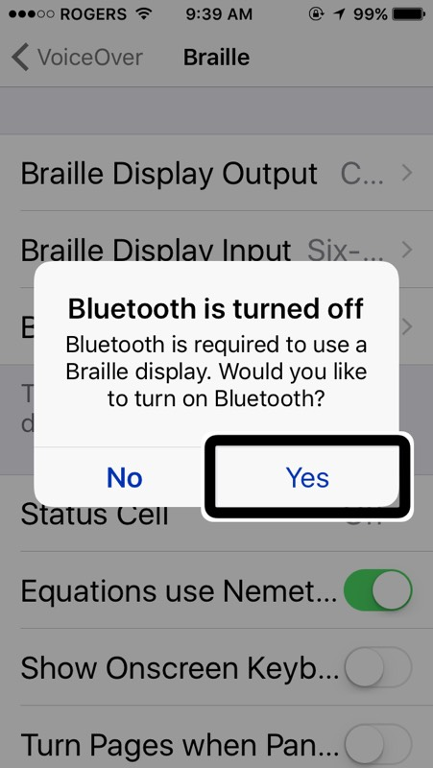
- Double tap the Brailliant/BrailleNote Touch when displayed in the list.  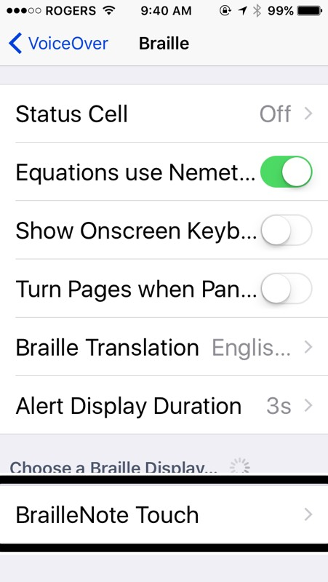 | - Double tap on the Pair button to confirm pairing. On your Touch, a pairing request will appear. Select the Pair button and press Enter to complete the pairing process. The PIN code will not appear on your Braille display.  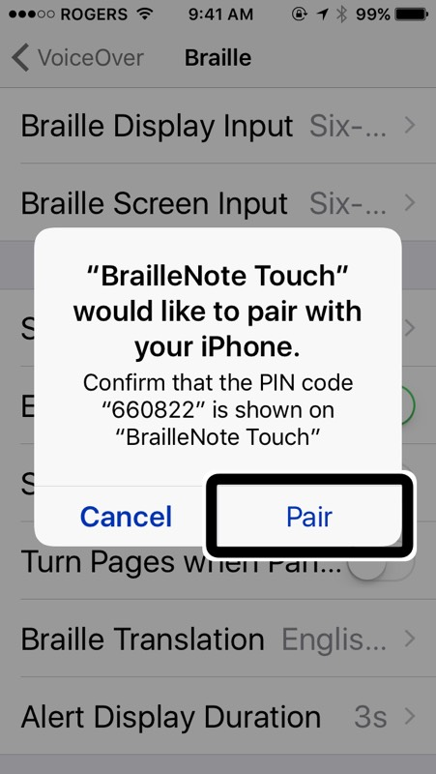

- The Brailliant/BrailleNote Touch will now show as paired in the list of Braille devices and the iOS device can now be controlled by the Touch input keyboard. The Touch's Braille display will represent in Braille everything that is spoken by the VoiceOver screen reader. Note that if the iOS device is locked, pressing the Home button on the iOS device will unlock the device and the Touch will automatically reconnect to it as a Braille device.
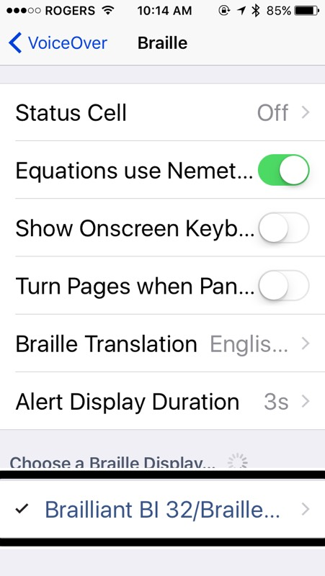

Command Summary

JAWS command summary
Below is the command summary for the BrailleNote Touch to be used as refreshable Braille display with JAWS. It includes JAWS commands, Windows commands, reading commands, and navigation commands, and more.
Your BrailleNote can also be used to type text into the PC applications or to simulate the PC keyboard.
You can also define your own commands in the keyboard configuration utility of the JAWS options.

Basic Commands

Braille navigation
Prior line: Outer Left Thumb Key (Previous)
Move left: Inner Left Thumb Key (Left)
Move right: Inner Right Thumb Key (Right)
Next line: Outer Right Thumb Key (Next)
Move left on current line: Outer Left Thumb Key (Previous) + Inner Left Thumb Key (Left)
Move right on current line: Inner Right Thumb Key (Right) + Outer Right Thumb Key (Next)
Routing cursors: Route Braille to position of active cursor
Active follows Braille: Outer Left Thumb Key (Previous) + Outer Right Thumb Key (Next)
Braille follows active: Inner Left Thumb Key (Left) + Inner Right Thumb Key (Right)

Windows commands
Start Menu: Space with Dots 3-4
Menu Bar: Space with M
Minimize All Apps: Space with D
Enter: Dot 8
Backspace: Dot 7
Escape: Space with E
Alt-Tab: Space with T
Open list or combo box: Space with O
Close list or combo box: Space with Dots 2-4-6
Application key: Space with M and Dot 7

Navigation commands
Tab: Space with Dots 4-6
Shift-Tab: Space with K
Top of file: Space with L
Bottom of file: Space with Dots 4-5-6
Home: Space with Dots 2-3
End: Space with Dots 5-6
Page-Up: Space with B
Page-Down: Space with Dots 4-5
Next document window: Space with Dots 1-2-5-6
Previous Document Window: Space with Dots 1-6
Close document window: Space with Q
Move Braille display to top line of screen: Space with Dots 2-3
Move Braille display to bottom line of screen: Space with Dots 5-6

Reading commands
Say prior character: Space with Dot 3
Say next character: Space with Dot 6
Say prior line: Space with Dot 1
Say next line: Space with Dot 4
Say prior word: Space with Dot 2
Say Next Word: Space with Dot 5
Say all: Space with G
Toggle speech on and off: Space with F
Select a voice profile: Space with Dots 3-4-5-6

Cursor commands
Toggle between the JAWS and PC Cursor: Space with Dots 2-3-5-6
Route JAWS cursor to PC: Space with P
Route Braille to active cursor: Space with R

Braille commands
Braille toggle mode (Line, Structured, Speech History, Attribute): Space with Dots 2-5
Toggle between contracted and uncontracted Braille: Space with U
Expand current Grade 2 word: Space with W
Change contracted Braille setting: Space with N
Toggle between 6 and 8 dots: Space with Dots 2-3-5
Indicate which text attributes should be displayed: Space with Dots 3-6
Set Braille Verbosity: Space with Dots 1-2-3-4-6
Start Braille auto advance: Space with Dots 1-2-4-5-6
Increase Braille Auto Advance Speed: Space with Dots 3-4-5
Decrease Braille Auto Advance Speed: Space with Dots 1-2-6

Information commands
Keyboard Help: Space with Dots 3-5-6
Say title of the active window: Space with I
Say system time: Space with Z
List task tray icons: Space with Y
Hotkey Help: Space with Dots 2-3-6
JAWS window: Space with J
Start JAWS task list: Space with S
Read dialog box in tab order: Space with Dots 2-3-4-6

Edit commands
Cut to clipboard: Space with X
Copy to clipboard: Space with C
Paste from clipboard: Space with V
Delete: Space with D and Dot 7
Caps lock toggle: Space with Dot 7

Internet Explorer commands
Go back: Space with Dots 1-2-3-5-6
Go forward: Space with Dots 2-3-4-5-6
List links on a webpage: Space with Dots 3-4-6
List frames on a webpage: Space with Dots 1-5-6

PC keyboard emulation for the Touch
Entering text using your Touch's keyboard is very straightforward. Typing characters, changing lines, deleting characters, entering uppercase characters, and moving inside the text. JAWS simultaneously updates the Braille display to reflect what you type.
With the help of JAWS, you can enter Braille commands and control your computer using sets of keystrokes.

Modifier Keys
Modifier keys are used to emulate keystroke combinations that include CTRL, ALT, WINDOWS Key, SHIFT, the JAWS Key and the INSERT key. To make use of modifiers when entering text, follow these instructions:
- Press and hold SPACE with DOT 8 followed by the corresponding modifier keys.
Once you have entered the modifier, release the keys then press the remaining portion of the keystroke. To enter CTRL+SHIFT+A, for example, you will need to press SPACE with DOTS 3-7-8, release the keys, then press A (DOT 1).
SHIFT: Space with Dots 7-8
CTRL: Space with Dots 3-8
ALT: Space with Dots 2-8
WINDOWS Key: Space with Dots 1-8
Function Keys (F1 through F12): Space with Dots 4-8
JAWS Key: Space with Dots 5-8
INSERT Key: Space with Dots 6-8

Function Keys
To emulate the Function keys (F1 through F12), press SPACE with DOTS 4-8 followed by the letters A through L (representing 1 through 12). If you wish to emulate the F7 key, press SPACE with DOTS 4-8, followed by G (DOTS 1-2-4-5). If you are combining a function key with another, you just need to enter the necessary modifiers while pressing down SPACE with DOTS 4-8. If you wish to emulate INSERT+F3, press SPACE with DOTS 4-5-8, followed by C (DOTS 1-4).

Modifier commands
The following commands can be used in combination with modifier keys:
Up Arrow: Space with Dot 1
Down Arrow: Space with Dot 4
Left Arrow: Space with Dot 3
Right Arrow: Space with Dot 6
Home: Space with Dots 2-3
End: Space with Dots 5-6
Page-Up: Space with Dots 1-2
Page-Down: Space with Dots 4-5
Enter: Dot 8
Backspace: Dot 7
Delete: Space with D
Escape: Space with E
Tab: Space with Dots 4-6
Shift-Tab: Space with K

VoiceOver iOS command summary
You can use your BrailleNote Touch with the following Apple iOS products: iPod touch, iPhone and iPad.

Basic navigation commands
Move to previous item: Outer Left Thumb Key (Previous) or Space with Dot 1
Move to next item: Outer Right Thumb Key (Next) or Space with Dot 4
Pan Braille to the left: Inner Left Thumb Key (Left) or Space with Dot 2
Pan Braille to the right: Inner Left Thumb Key (Right) or Space with Dot 5
Double tap the selected item: Routing cursor or Space with Dots 3-6
Activate the Home button: Space with H
Launch the task switcher: Space with H twice quickly
Go to the control center: Space with Dots 2-5
Go to Notification Center: Space with Dots 4-6
Move to the first element: Space with Dots 1-2-3
Move to the last element: Space with Dots 4-5-6
Scroll left one page: Space with Dots 2-4-6
Scroll right one page: Space with O
Activate the Return key: Space with Dot 8 or Space with E
Activates a Back button if present or Escape current context: Space with B
Touch and Hold on the current element: Space with Dots 3-6-7-8
Move to Left Split View App (iPad only): Space with Dots 3-5
Move to Right Split View App (iPad only): Space with Dots 2-6
Item chooser: Space with I

Reading commands
Read page starting at selected item: Space with R
Read page starting at the top: Space with W
Scroll down one page: Space with Dots 1-4-5-6
Scroll up one page: Space with Dots 3-4-5-6
Pause or Continue speech: Space with P

Information commands
Go to the Status bar: Space with S
Start VoiceOver help: Space with K
Quit VoiceOver help: Space with B
Speak page number or rows being displayed: Space with Dots 3-4

Rotor commands
Move to previous item using rotor setting: Space with Dot 3 or thumb keys Previous and Left
Move to next item using rotor setting: Space with Dot 6 or thumb keys Next and Right
Select previous rotor setting: Space with Dots 2-3
Select next rotor setting: Space with Dots 5-6

Edit commands
Select right: Space with Dots 3-5-6
Select left: Space with Dots 2-3-6
Select all: Space with Dots 2-3-5-6
Cut: Space with X
Copy: Space with C
Paste: Space with V
Activate the Delete key: Space with Dot 7 or Space with D
Undo typing: Space with Z
Redo typing: Space with Dots 2-3-4-6

Miscellaneous commands
Toggle speech on and off: Space with M
Toggle Screen Curtain on and off: Space with Dots 1-2-3-4-5-6
Start and stop the current action: Space with Dots 1-5-6
Cycle through the available Braille output modes: Space with G
Cycle through the available Braille input modes: Space with Dots 2-3-6
Translate Braille: Space with Dots 4-5
Toggle expanded status description when Status cells are activated: Status Routing cursors
Output text style: Space with Dots 2-3-4-5-6
3D Touch on selected item: Space with Dots 3-5-6
Toggle quick nav on or off: Space with Q
Toggle Single letter quick nav: Space with Q and Dot 7
Activate the Tab key: Space with T
Activate the Shift with Tab keys: Space with Dots 1-2-5-6
Toggle announcement history: Space with N
Change an item's label: Space with Dots 1-2-3-4-6
Text search: Space with F
Activates the Eject key: Space with Dots 1-4-6
Activate the Volume Up button: Space with Dots 3-4-5
Activates the Volume Down button: Space with Dots 1-2-6
Move to previous container (iPad only): Space with Dots 1-7
Move to next container (iPad only): Space with Dots 4-7

